Community Carer Awareness Webinar

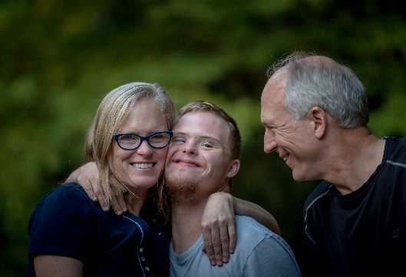
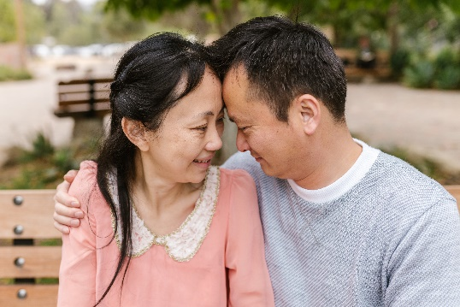
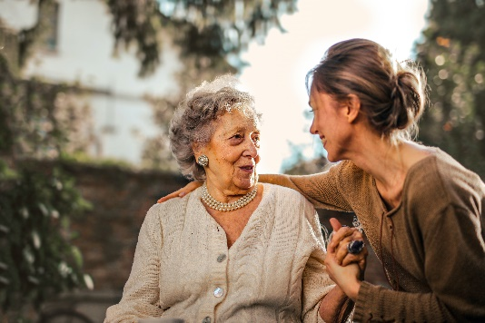

According to Carers UK informal Carers save the national economy £132 billion per year.

3 in 5 people will have a caring role or be affected by a caring role at some point in their lives.

69% of carers responding to the Carers Week survey reported poor mental health, while 64% said their physical health had deteriorated.

With this in mind, Nottinghamshire Carers Association would like to work with your organisation to support unpaid or informal carers across the county.

We can provide you and your team with Carer Awareness Training, signposting resources and support to work towards our ‘Carer Friendly Organisation’ Quality Mark, all of which are completely free to yourself and your team.

To sign up to one of our upcoming free on line Community Carer Awareness Training sessions please click on one of the Eventbrite links below. Training lasts approximately 50 mins, and is the first step towards your organisation being recognised across Nottinghamshire as ‘Carer Friendly’.

Tuesday 11th October 1.30pm – Click here

Thursday 3rd November 10.30am – Click here

To find out more about Nottinghamshire Carers Association head to www.nottinghamshirecarers.co.uk or email info@nottinghamshirecarers.co.uk.

